Below are sample posts and graphics you can copy and paste to any social account.

Post A

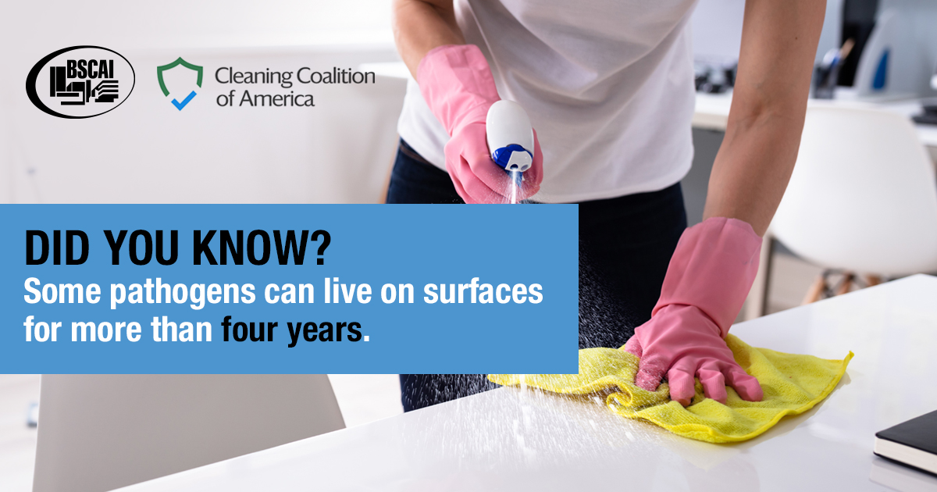

Disinfecting kills 99.9% of viruses and bacteria, including COVID-19, E. coli and salmonella. As a member of BSCAI and the Cleaning Coalition of America, [company] is deploying market-leading practices that protect public health and mitigate the spread of pathogens.

Post B

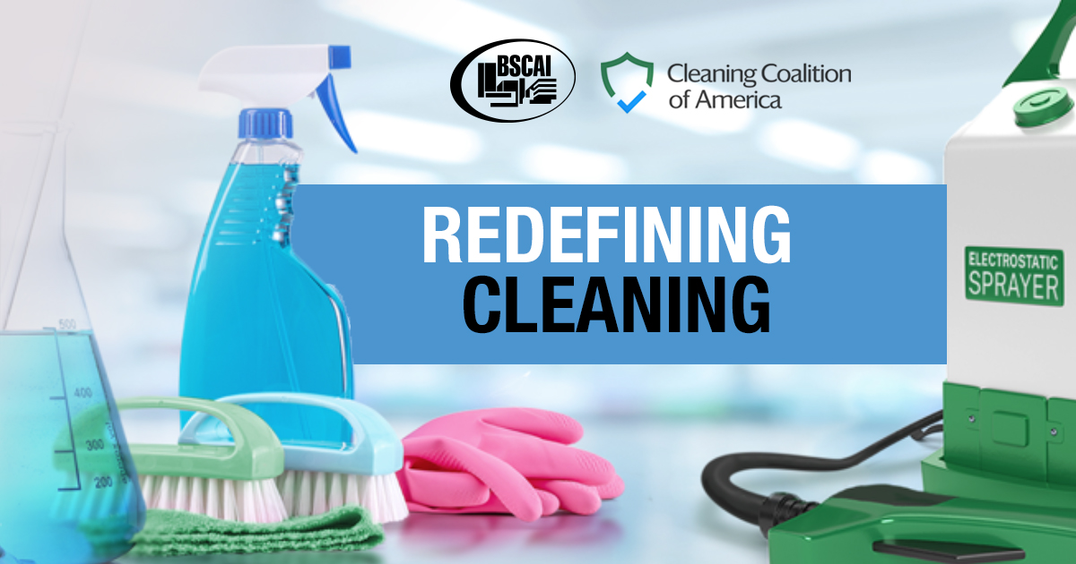

As a member of BSCAI and the Cleaning Coalition of America, [company] is working with experts to champion best-in-class disinfecting procedures. With EPA certified disinfectants, enhanced training and equipment, we are redefining clean and creating healthier spaces for the future.

Post C

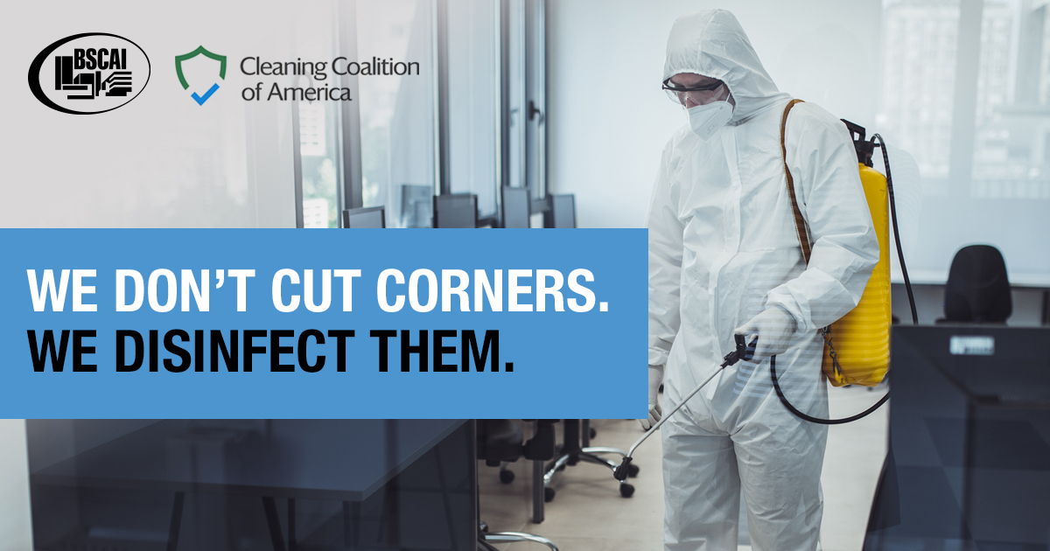

While cleaning with soap and water can remove pathogens, disinfecting kills them. Nobody understands this better than members of BSCAI and the Cleaning Coalition of America. At [company], we are championing enhanced disinfecting protocols and procedures that protect public health.

